**Blue Cod**

**Fisheries (Amateur Fishing) Regulations**

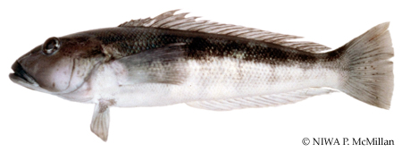  
  
“Blue cod” means the fish of which the scientific name is *Parapercis colias*:

|  |  |  |
| --- | --- | --- |
| **Size Limits** | | |
| National | **33 cm** | |
| [Marlborough Sounds Area](http://www.fish.govt.nz/en-nz/Recreational/Most+Popular+Species/Blue+Cod/Default.htm) | **30 - 35cm** | |
| South-East FMA, Challenger east | **30cm** | |
| Auckland & Kermadec | **30cm** | |
| **Daily Bag Limits (within the combined daily bag limit for finfish applicable in each area)** | | |
| Auckland and Kermadec FMA | **20** | |
| [Marlborough Sounds Area](http://www.fish.govt.nz/en-nz/Recreational/Most+Popular+Species/Blue+Cod/Default.htm) | **1** | |
| Central FMA | **10** | |
| Challenger East | **3** | |
| Challenger West | **20** | |
| South-East FMA. | **30** | |
| Kaikoura/Nth Canterbury | **10** | |
| Southland and Sub-Antarctic FMA | **20** | |
| **Daily Species Limits** | | | |
| [Marlborough Sounds Area](http://www.fish.govt.nz/en-nz/Recreational/Most+Popular+Species/Blue+Cod/Default.htm) | | **2** | |
| Challenger (East) Area | | **6** | |
| Kaikoura-North Canterbury Area | | **10** | |
| Te Whaka a Te Wera/ Paterson Inlet Mataitai Reserve, Stewart Island | | **10** | |
| Fiordland Marine Area | | **20** (within finfish bag limit of 30/ No accumulation) | |
| Fiordland Marine Area Internal Waters | | **3** | |

**“Blue cod pot”-**

Means any pot (whether baited or not) that is capable of catching or holding blue cod; and includes any other device capable of catching, holding, or storing blue cod; but Does not include a rock lobster pot.

**Blue Moki**

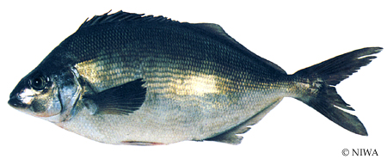  
  
“Blue moki” means the fish of which the scientific name is *Latridopsis ciliaris*:

|  |  |
| --- | --- |
| **Net mesh size** | |
| National | **115 mm** |
| Auckland and Kermadec FMA | **114 mm** |
| Central FMA | **114 mm** |
| Challenger FMA | **114 mm** |
| South-East FMA | **114 mm** |
| Southland and Sub-Antarctic FMA | **114 mm** |
| **Size Limits** | |
| National | **40 cm** |
| **Daily Bag Limits** | |
| Auckland and Kermadec FMA | **20** |
| Central FMA | **20** |
| Challenger FMA | **20** |
| South-East FMA | **15/30** |
| Southland and Sub-Antarctic FMA | **15/30** |

**Bluenose**

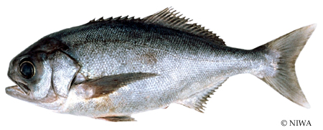  
  
“Bluenose” means a fish of the species *Hyperoglyphe antarctica*:

|  |  |
| --- | --- |
| **Net mesh size** | |
| Auckland and Kermadec FMA | **160 mm** |
| Central FMA | **160 mm** |
| Challenger FMA | **160 mm** |
| South-East FMA | **160 mm** |
| Southland and Sub-Antarctic FMA | **160 mm** |
| **Size Limits** | |
| National | **Nil** |
| **Daily Bag Limits  (within the combined daily bag limit for finfish applicable in each area)** | |
| Auckland and Kermadec FMA | **5** |
| Central FMA | **5** |
| Challenger FMA | **5** |
| South-East FMA | **5** |
| Southland and Sub-Antarctic FMA | **5** |

**Butterfish (Greenbone)**

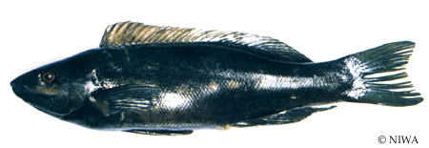  
  
“Butterfish” means those fish of which the scientific names are Odax pullus or Odax cyanoallix:

|  |  |
| --- | --- |
| **Net mesh size** | |
| National | **108 mm** |
| **Size Limits (Length)** | |
| National | **35 cm** |
| **Daily Bag Limits** | |
| Auckland and Kermadec FMA | **20** |
| Central FMA | **20** |
| Challenger FMA | **20** |
| South-East FMA | **15/30** |
| Southland and Sub-Antarctic FMA | **15/30** |

**Cockle**

|  |  |
| --- | --- |
| Cockle.   “Cockle” means the mollusc *Chione (Austrovenus) stuchburyi*:  **Net mesh size** | |
| National | **Not applicable** |
| **Size Limits (Length)** | |
| National | **Nil** |
| **Daily Species limit** | |
| National | **150** |
| Auckland Coromandel | **50** |

**Elephant Fish**

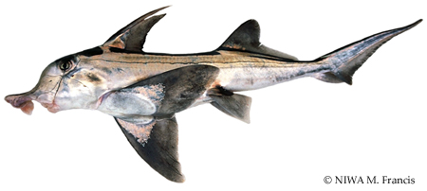  
  
“Elephant fish” means the fish of which the scientific name is *Callorhynchus milii*:

|  |  |
| --- | --- |
| **Net mesh size** | |
| National | **150 mm** |
| **Size Limits (Length)** | |
| National | **Nil** |
| **Daily Bag Limits** | |
| Auckland and Kermadec FMA | **20** |
| Central FMA | **20** |
| Challenger FMA | **20** |
| South-East FMA | **5/30** |
| Southland and Sub-Antarctic FMA | **5/30** |

# Garfish (Piper)

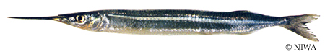  
  
“Garfish” means the fish of which the scientific name is Hyporhamphus ihi (commonly known as piper):

|  |  |
| --- | --- |
| **Net mesh size** | |
| National | **25 mm** |
| **Size Limits (Length)** | |
| National | **Nil** |

**Approved methods may be used vicinity of Mimiwhangata Peninsula -**

1. Lines, if only 1 hook attached to it and the line is not weighted in any way:
2. Trolling:
3. Spears:
4. Hand-gathering:
5. Potting, if only 1 pot per person, part, or vessel is used in the area.

# Grey Mullet

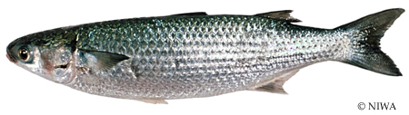  
  
“Mullet” includes those fish of which the scientific names are Mugil cephalus (commonly known as the grey mullet), and Upeneichthys lineatus (commonly known as the goatfish or red mullet); but does not include the yellow-eyed mullet (Aldrichetta forsteri):

|  |  |
| --- | --- |
| **Net mesh size** | |
| National | **85 mm** |
| Auckland and Kermadec FMA | **90 mm** |
| Central FMA | **100 mm** |
| Challenger FMA | **100 mm** |
| South-East FMA | **90 mm** |
| Southland and S-Antarctic FMA | **90 mm** |
| **Size Limits (Length)** | |
| National | **Nil** |
| **Daily Bag Limits** (associated with Kingfish) | |
| Central FMA | **20** |
| Challenger FMA | **20** |
| South-East FMA | **30** |
| Southland and Sub-Antarctic FMA | **30** |
| **Daily Species limit** | |
| Auckland and Kermadec FMA | **30** |

# Hapuku (Groper)

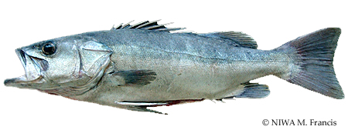  
  
“Hapuku/bass” means a fish of the species Polyprion oxygeneios or Polyprion moene:

|  |  |  |
| --- | --- | --- |
| **Net mesh size** | | |
| National | **100 mm** (all other) | |
| Auckland and Kermadec FMA | **160 mm** | |
| Central FMA | **160 mm** | |
| Challenger FMA | **160 mm** | |
| South-East FMA | **160 mm** | |
| Southland and S-Antarctic FMA | **160 mm** | |
| **Size Limits (Length)** | | |
| National | **Nil** | |
| **Daily Bag Limits** (associated with Kingfish) | | | |
| Auckland and Kermadec FMA | | **5** | |
| Central FMA | | **5** | |
| Challenger FMA | | **5** | |
| South-East FMA | | **5** | |
| Southland and Sub-Antarctic FMA | | **5** | |
| Fiordland Marine Area | | **5** (within finfish bag limit of 30/ No accumulation) | |
| Fiordland Marine Area Internal Waters | | **3** | |

# John Dory

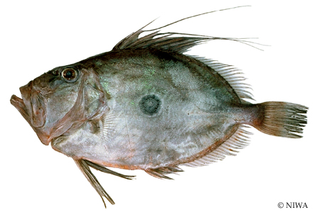  
  
“John dory” means a fish of the species Zeus faber

|  |  |
| --- | --- |
| **Net mesh size** | |
| National | **100 mm** (all other) |
| **Size Limits (Length)** | |
| National | **NIL** |
| **Daily Bag Limits** | |
| Auckland and Kermadec FMA | **20** |
| Central FMA | **20** |
| Challenger FMA | **20** |

# Kahawai

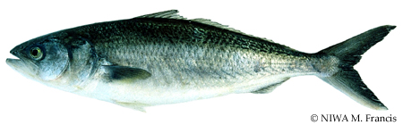  
  
“Kahawai” means the fish of which the scientific name is Arripis trutta:

|  |  |
| --- | --- |
| **Net mesh size** | |
| National | **85 mm** |
| Auckland and Kermadec FMA | **90 mm** |
| Central FMA | **100 mm** |
| Challenger FMA | **100 mm** |
| South-East FMA | **90 mm** |
| Southland and S-Antarctic FMA | **90 mm** |
| **Size Limits (Length)** | |
| National | **Nil** |
| **Daily Bag Limits** (associated with Kingfish) | |
| Auckland and Kermadec FMA | **20** |
| Central FMA | **20** |
| Challenger FMA | **20** |
| South-East FMA | **15/30** |
| Southland and Sub-Antarctic FMA | **15/30** |

# Kina

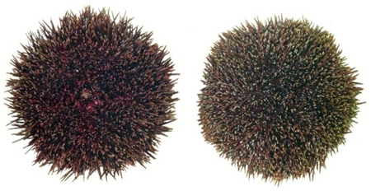  
  
“Kina” means the shellfish of which the scientific name is Evechinus chloroticus (commonly known as the sea egg); and includes the purple urchin, of which the scientific name is Centrostephanus rodgersii:

|  |  |
| --- | --- |
| **Net mesh size** | |
| National | **Not applicable** |
| **Size Limits (Length)** | |
| National | **Nil** |
| **Daily Species limit** | |
| National | **50** |

# Kingfish

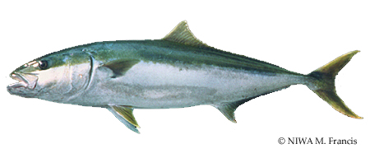  
  
“Kingfish” means a fish of the species Seriola lalandi:

|  |  |
| --- | --- |
| **Net mesh size** | |
| National | **100 mm** |
| **Size Limits (Length)** | |
| National | **75 cm** |
| **Daily Bag Limits** (associated with Hapuku) | |
| Auckland and Kermadec FMA | **3** |
| Central FMA | **3** |
| Challenger FMA | **3** |
| South-East FMA | **3** |
| Southland and Sub-Antarctic FMA | **3** |

**Lemon Sole**

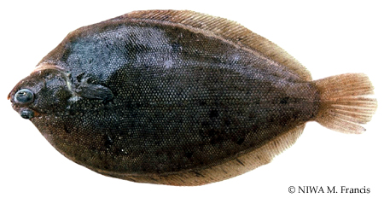  
  
“Flatfish” includes the following species:

* Sand flounder (“dab”, “white”, “diamond”, or “square” flounder) (*Rhombosolea plebeia*):
* Lemon sole (*Pelotretis flavilatus*):
* New Zealand sole (*Peltorhamphus novaezeelandiae*):
* Flounder (“yellow belly”) (*Rhombosolea leporina*):
* Brill (*Colistium guntheri*):
* Turbot (*Colistium nudipinnis*):
* Black flounder (*Rhombosolea retiaria*):
* Greenback flounder (*Rhombosolea tapirinia*):

|  |  |
| --- | --- |
| **Net mesh size** | |
| National | **100 mm** |
| Auckland and Kermadec FMA | **114 mm** |
| **Size Limits (Length)** | |
| Flatfish (except sand flounder) | **25cm** |
| **Daily Bag Limits** | |
| Auckland and Kermadec FMA | **20** |
| Central FMA | **20** |
| Challenger FMA | **20** |
| South-East FMA | **30** |
| Southland and Sub-Antarctic FMA | **30** |
| Te Whaka a Te Wera/ Paterson Inlet Mataitai Reserve, Stewart Island | **10** Flatfish |

# Mussel

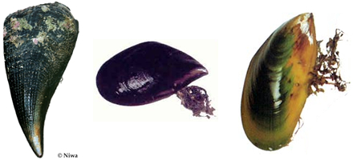  
  
“Mussel” means the green mussel (Perna canaliculus), the blue mussel (Mystilus edulis aoteanus), and the horse mussel (Atrina zelandica):

|  |  |
| --- | --- |
| **Size Limits (Length)** | |
| National | **Nil** |
| **Daily Species limit** | |
| National | **50** |
| Auckland Coromandel Area | **25** (Green lipped) |
| Southland FMA | **25** |
| Stewart Island | **50** |

# Dredge Oyster

|  |  |
| --- | --- |
| Dredge Oyster.   “Oyster” includes the kinds of molluscs known as Saccostrea glomerata (formerly known as Crassostrea glomerata or Saxostrea glomerata) and Crassostrea gigas, commonly known as the rock oyster and Pacific oyster respectively; and Tiostrea chilensis (formerly known as Ostrea lutaria), commonly known as the dredge oyster:   **Size Limits (Length)**  A person must not take or possess any dredge oyster that can be passed through a rigid circular metal ring having a clear inside diameter of 58 mm.  **Daily Species limit** | |
| National | **50** |

**Oyster Season**  
Within the Southland FMA the open season for oysters is from the 1st March to 31st August inclusive.  
  
**Note**  
Dredge Oysters taken in the South East FMA have no restriction on either size or season.

# Pacific Oyster

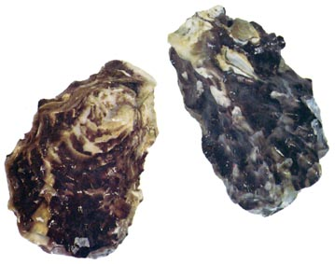  
  
“Oyster” includes the kinds of molluscs known as Saccostrea glomerata (formerly known as Crassostrea glomerata or Saxostrea glomerata) and Crassostrea gigas, commonly known as the rock oyster and Pacific oyster respectively; and Tiostrea chilensis (formerly known as Ostrea lutaria), commonly known as the dredge oyster:

|  |  |
| --- | --- |
| **Size Limits (Length)** | |
| National | **Nil** |
| **Daily Species limit** | |
| National | **250** |

**Note**  
No Rock or Pacific Oysters are known to exist in the South-East FMA or Southland FMA.

# Ordinary and Yellow Foot Paua

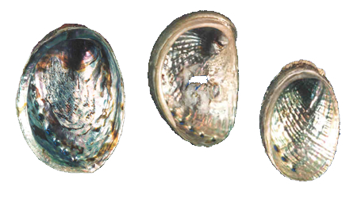  
  
“Paua” means ordinary paua (Haliotis iris), yellow foot paua (Haliotis australis), and virgin paua (Haliotis virginea):

|  |  |  |  |
| --- | --- | --- | --- |
| **Size Limits** | | | |
| “Length”, In relation to any paua, the greatest overall length of the shell measured on a plane parallel to the ventral surface of the paua: | | | |
| - Ordinary | | **125 mm** | |
| - Yellow foot | | **80 mm** | |
| **Daily Species limit** | | | |
| National | - ordinary | | **10** |
|  | - yellow foot | | **10** |
| Te Whaka a Te Wera/ Paterson Inlet Mataitai Reserve, Stewart Island | | | **5** |
| Fiordland Marine Area | | | **10** (No accumulation) |

**Method Restriction**  
No person shall use any: or possess underwater breathing apparatus while in possession of paua or mussels.

# Paua Species Identification

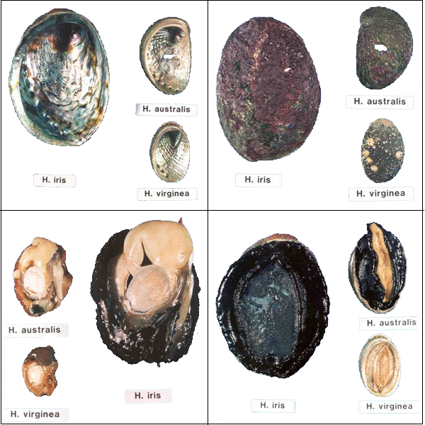

# Pilchard

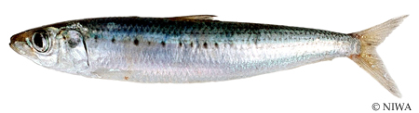  
  
“Pilchard or sardine” means the fish of which the scientific name is Sardinops neopilchardus; and includes the fish commonly known as sprat (Sprattus spp.):

|  |  |
| --- | --- |
| **Minimum net mesh size** | |
| Pilchard | **25** |

No minimum size.

# Pipi

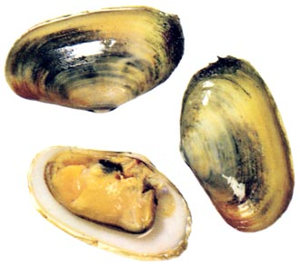  
  
“Pipi” means the mollusc Paphies australis:

|  |  |
| --- | --- |
| **Daily Species limit** | |
| National | **150** |
| Auckland Coromandel Area | **50** |

|  |  |
| --- | --- |
| **Size Limits (Length)** | |
| National | **Nil** |

# Quinnat Salmon

“Quinnat salmon” (also known as Chinook salmon) means the fish of which the scientific name is Oncorhynchus tshawytscha:   
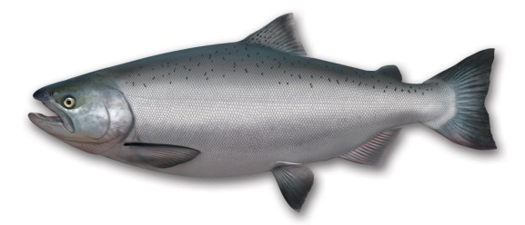 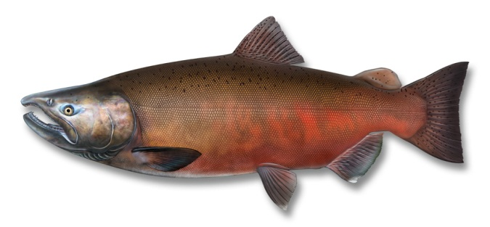

|  |  |
| --- | --- |
| **Net mesh size** | |
| National | **Not entitled to use** |
| **Size Limits (Length)** | |
| National | **Nil** |
| Otago Harbour | **45 cm** |
| **Daily Species limit** | |
| National | **4** |
| **Daily Bag Limits** | |
| South-East FMA | **2/30** |
| Southland and Sub-Antarctic FMA | **2/30** |

**Method**  
No person shall take Quinnat salmon by any method other than a rod and running line.

# Red Cod

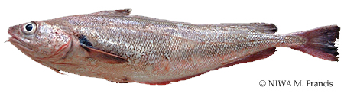  
  
“Red cod” means the fish of which the scientific name is Pseudophycis bachus.

|  |  |
| --- | --- |
| **Net mesh size** | |
| National | **100 mm** |
| **Size Limits (Length)** | |
| National | **25 cm** |
| **Daily Bag Limits** | |
| Auckland and Kermadec FMA | **20** |
| Central FMA | **20** |
| Challenger FMA | **20** |
| South-East FMA | **10** |
| Southland and Sub-Antarctic FMA | **10** |

# Red Gurnard

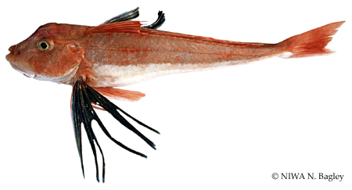  
  
“Red gurnard” means a fish of the species Chelidonichthys kumu

|  |  |
| --- | --- |
| **Net mesh size** | |
| National | **100 mm** (all Other) |
| **Size Limits (Length)** | |
| National | **25 cm** |
| **Daily Bag Limits** | |
| Auckland and Kermadec FMA | **20** |
| Central FMA | **20** |
| Challenger FMA | **20** |
| South-East FMA | **30** |
| Southland and Sub-Antarctic FMA | **30** |

# Red Moki

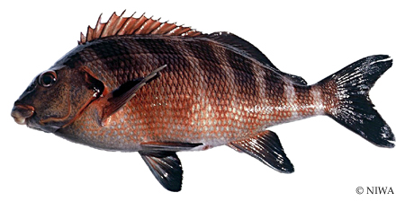  
  
“Red moki” means the fish of which the scientific name is Cheilodactylus spectabilis

|  |  |
| --- | --- |
| **Net mesh size** | |
| National | **115 mm** |
| **Size Limits (Length)** | |
| National | **40 cm** |
| **Daily Bag Limits** | |
| Auckland and Kermadec FMA | **20** |
| Central FMA | **20** |
| Challenger FMA | **20** |
| South-East FMA | **15/30** |
| Southland and Sub-Antarctic FMA | **15/30** |

# Rig or Spotted Dogfish

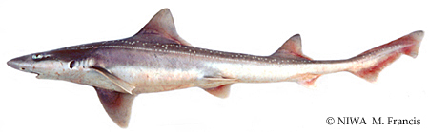  
  
“Rig” means the fish of which the scientific name is Mustelus lenticulatus:

|  |  |
| --- | --- |
| **Net mesh size** | |
| National | **150 mm** |
| Auckland and Kermadec FMA | **125 mm** |
| **Size Limits (Length)** | |
| National | **Nil** |
| **Daily Bag Limits** (associated with Kingfish) | |
| Auckland and Kermadec FMA | **20** |
| Central FMA | **20** |
| Challenger FMA | **20** |
| South-East FMA | **5/30** |
| Southland and Sub-Antarctic FMA | **5/30** |

**Packhorse Rock Lobster**

“Packhorse rock lobster” means the fish of which the scientific name is *Jasus verreauxi* (commonly known as the packhorse or green rock lobster), and includes any part thereof.  
  
**No person shall take or possess -**

* Any undersize:
* Carrying external eggs, or from which external eggs have been removed
* Any egg-bearing appendage or pleopod has been removed
* Tail is in such a state that the sex of the rock lobster cannot be determined
* The calcified bar or first abdominal segment of the tail is fractured
* is in such a state that its tail cannot be properly measured
* In the soft shell stage.

|  |  |
| --- | --- |
| **Closed Season**  Chatham Islands rock lobster fishery March and April in any year;  **Size Limits (Length)** | |
| National |  |
| Packhorse length | **216 mm** |
| **Daily Species limit** | |
| National | **6** |

**Spiny Rock Lobster**

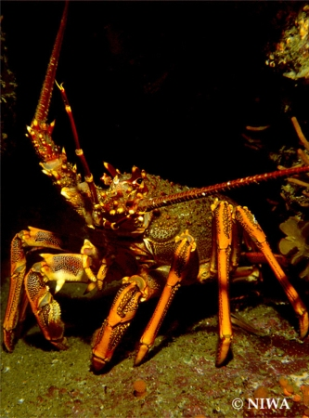  
  
“Spiny rock lobster” means the fish of which the scientific name is *Jasus edwardsii* (commonly known as the spiny or red rock lobster), and includes any part thereof:   
  
**No person shall take or possess -**

* Any undersize:
* Carrying external eggs, or from which external eggs have been removed
* Any egg-bearing appendage or pleopod has been removed
* Tail is in such a state that the sex of the rock lobster cannot be determined
* The calcified bar or first abdominal segment of the tail is fractured
* is in such a state that its tail cannot be properly measured
* In the soft shell stage.

|  |  |
| --- | --- |
| **Closed Season**  Chatham Islands rock lobster fishery March and April in any year;  **Size Limits (Length)** | |
| National |  |
| Female spiny r/l width | **60 mm** |
| Male spiny r/l width | **54 mm** |
| **Daily Species limit** | |
| National | **6** |
| Fiordland Marine Area | **6** (within 3-day or more accumulation limit 0f 15) |
| Fiordland Marine Area Internal Waters | **3** |

# Rock Lobster Measurement

For the purposes of the regulations the width of the tail of a spiny rock lobster is the distance measured in a straight line from the tip of 1 primary pleural spine on the second abdominal segment of the tail to the tip of the other primary pleural spine on that segment.

# Rock Lobster Size Limits

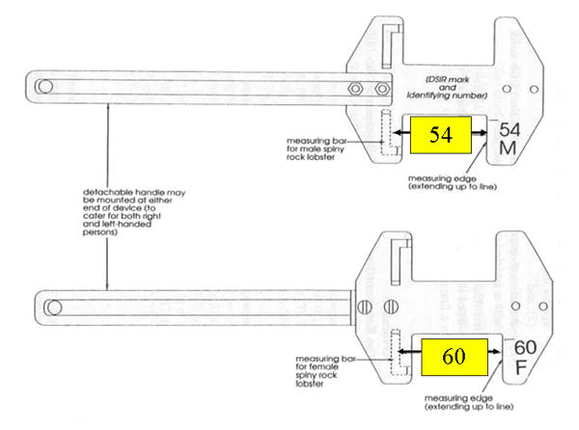

**Sand Flounder**

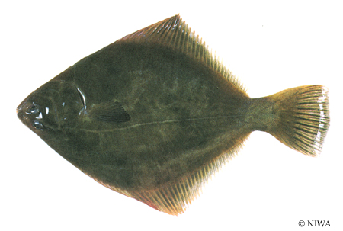  
  
“Flatfish” includes the following species:

* Sand flounder (“dab”, “white”, “diamond”, or “square” flounder) (*Rhombosolea plebeia*):
* Lemon sole (*Pelotretis flavilatus*):
* New Zealand sole (*Peltorhamphus novaezeelandiae*):
* Flounder (``yellow belly'') (*Rhombosolea leporina*):
* Brill (*Colistium guntheri*):
* Turbot (*Colistium nudipinnis*):
* Black flounder (*Rhombosolea retiaria*):
* Greenback flounder (*Rhombosolea tapirinia*):

|  |  |
| --- | --- |
| **Net mesh size** | |
| National | **100 mm** |
| Auckland and Kermadec FMA | **114 mm** |
| **Size Limits (Length)** | |
| Sand flounder | **23 cm** |
| **Daily Bag Limits** | |
| Auckland and Kermadec FMA | **20** |
| Central FMA | **20** |
| Challenger FMA | **20** |
| South-East FMA | **30** |
| Southland and Sub-Antarctic FMA | **30** |
| Te Whaka a Te Wera/Paterson Inlet Mataitai Reserve, Stewart Island |  |

# Scallop

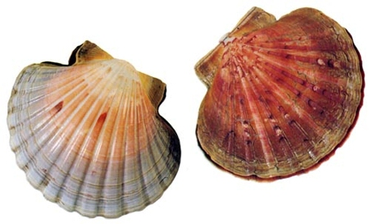  
  
“Scallop” means the mollusc Pecten novaezelandiae:

|  |  |  |
| --- | --- | --- |
| **Daily Species limit** | | |
| National | | **20** |
| Challenger FMA. | | **50** |
| Southland FMA | | **10** |
| **Size Limits (Length)** | | |
| `Length'', in relation to any scallop, the greatest diameter of the shell: | | |
| National | | **100 mm** |
| Challenger FMA | | **90 mm** |
| **Closed Season** | | | |
| There are regional differences throughout New Zealand and it is your responsibility to know what they are. [Select your fishing area.](http://www.fish.govt.nz/en-nz/Recreational/Fishery+Management+Areas/default.htm) |  | | |

# School Shark

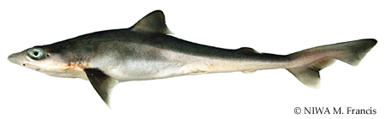  
  
“School shark” means a fish of the species Galeorhinus australis:

|  |  |
| --- | --- |
| **Net mesh size** | |
| National | **100 mm** (all other) |
| Auckland and Kermadec FMA | **125 mm** |
| Central FMA | **150 mm** |
| Challenger FMA | **150 mm** |
| South-East FMA | **150 mm** |
| Southland and Sub-Antarctic FMA | **150 mm** |
| **Size Limits (Length)** | |
| National | **Nil** |
| **Daily Bag Limits** | |
| Auckland and Kermadec FMA | **20** |
| Central FMA | **20** |
| Challenger FMA | **20** |
| South-East FMA | **5/30** |
| Southland and Sub-Antarctic FMA | **5/30** |

# Shortfin Eels

“Eel” means the shortfin eel (Anguilla australis) and the longfin eel (Anguilla dieffenbachii):

|  |  |
| --- | --- |
| **Net mesh size** | |
| National | **12 mm** |
| **Size Limits (Length)** | |
| National | **Nil** |
| **Daily Bag Limits** | |
| National | **6** |

No person shall take any eel from Lake Horowhenua or the Hokio Stream (unless that person does so in the exercise of the fishing rights).  
    
No person who does not belong to the Ngai Tahu iwi may take any eels from Lake Forsyth.

**Snapper**

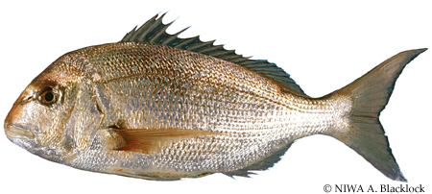  
  
“Snapper” means the fish of which the scientific name is *Chrysophrys auratus*

|  |  |
| --- | --- |
| **Net mesh size** | |
| National | **100 mm** |
| Auckland and Kermadec FMA | **125 mm** |
| South-East FMA | **125 mm** |
| Southland and Sub-Antarctic FMA | **125 mm** |
| **Size Limits (Length)** | |
| National | **25 cm** |
| Auckland and Kermadec FMA | **27 cm** |
| Central FMA | **27 cm** |
| **Daily Bag Limits** | |
| South-East FMA | **10** |
| Southland and Sub-Antarctic FMA | **30** |
| Challenger | **10** |
| Marlborough Sounds | **3** |
| **Daily Species limit** | |
| Auckland FMA (West) | **10** |
| Auckland FMA (East) | **9** |
| Central FMA | **10** |
| Challenger FMA | **10** |
| Marlborough Sounds Area | **3** |

**Approved methods may be used vicinity of Mimiwhangata Peninsula -**(a) Lines, if only 1 hook attached to it and the line is not weighted in any way:   
(b) Trolling:   
(c) Spears:   
(d) Hand-gathering:   
(e) Potting, if only 1 pot per person, part, or vessel is used in the area

**Tarakihi**

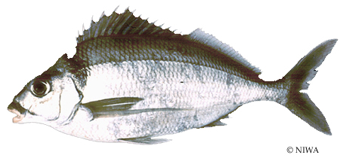  
  
“Tarakihi” means the fish of which the scientific name is *Nemadactylus macropterus*

|  |  |
| --- | --- |
| **Net mesh size** | |
| National | **100 mm** |
| **Size Limits (Length)** | |
| National | **25 cm** |
| **Daily Bag Limits** | |
| Auckland and Kermadec FMA | **20** |
| Central FMA | **20** |
| Challenger FMA | **20** |
| South-East FMA | **15/30** |
| Southland and Sub-Antarctic FMA | **15/30** |

**Approved methods may be used vicinity of Mimiwhangata Peninsula -**  
(a) Lines, if only 1 hook attached to it and the line is not weighted in any way:   
(b) Trolling:   
(c) Spears:   
(d) Hand-gathering:   
(e) Potting, if only 1 pot per person, part, or vessel is used in the area.

# Toheroa

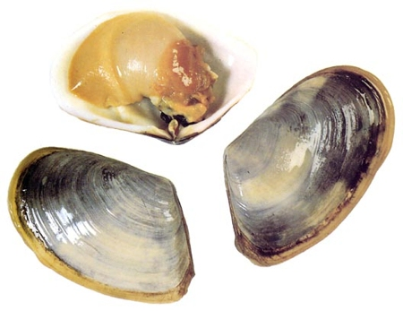  
  
“Toheroa” means the mollusc of which the scientific name is Paphies ventricosa:   
  
  
**Closed Season**   
A person must not take, possess, or disturb toheroa.

**Trevally**

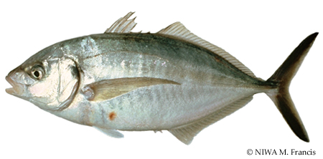  
  
“Trevally” means the fish of which the scientific name is *Caranx georgianus*.

|  |  |
| --- | --- |
| **Net mesh size** | |
| National | **100 mm** |
| Auckland and Kermadec FMA | **125 mm** |
| **Size Limits (Length)** | |
| National | **25 cm** |
| **Daily Bag Limits** | |
| Auckland and Kermadec FMA | **20** |
| Central FMA | **20** |
| Challenger FMA | **20** |
| South-East FMA | **30** |
| Southland and Sub-Antarctic FMA | **30** |

**Approved methods may be used vicinity of Mimiwhangata Peninsula -**(a) Lines, if only 1 hook attached to it and the line is not weighted in any way:   
(b) Trolling:   
(c) Spears:   
(d) Hand-gathering:   
(e) Potting, if only 1 pot per person, part, or vessel is used in the area.

**Tuatua**

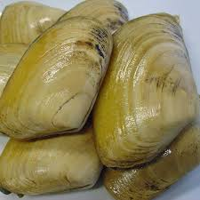

“Tuatua” means the mollusc *Paphies subtriangulata* and the mollusc *Paphies donacina* (commonly known as southern tuatua):

|  |  |
| --- | --- |
| **Daily Species limit** | |
| National | **150** |
| Auckland Coromandel Area | **50** |
| **Size Limits (Length)** | |
| National | **NIL** |

**Yellow Eyed Mullet (Herring)**

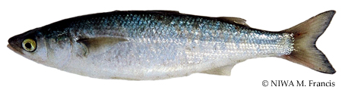  
  
“Herring” means the yellow-eyed mullet (*Aldrichetta forsteri*); but does not include the pilchard or sardine, or the species of mullet known as *Mugil cephalus* or *kanae*:

|  |  |
| --- | --- |
| **Net mesh size** | |
| National | **25 mm** |
| **Size Limits (Length)** | |
| National | **Nil** |
| **Daily Bag Limits** | |
| National | **Nil** |

**Approved methods may be used vicinity of Mimiwhangata Peninsula -**  
(a) Lines, if only 1 hook attached to it and the line is not weighted in any way:   
(b) Trolling:   
(c) Spears:   
(d) Hand-gathering:   
(e) Potting, if only 1 pot per person, part, or vessel is used in the area.

# Set Net

Every set net is required to have attached to each end of the net, a surface float that is legibly and permanently marked with that person's initials and surname.   
  
If a net is being used during Customary Fishing pursuant ( reg 27A only) to a customary Authorization the floats must be marked with a Customary Authorization (permit) Number.  
  
Every fyke net is required to have a surface float attached to it that is legibly and permanently marked with that person's initials and surname.